Lab 2 informatics screenshots. Akkushimov Viktor

B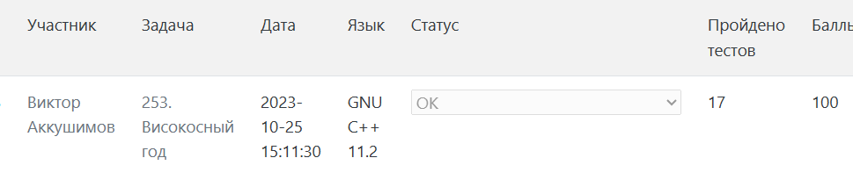

F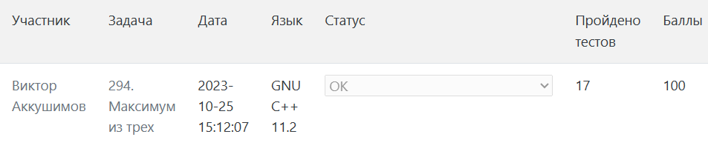

G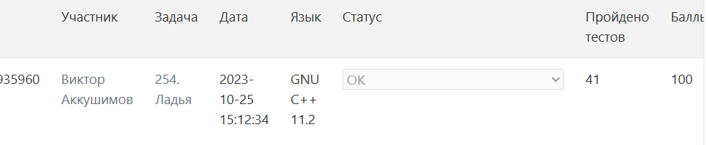

I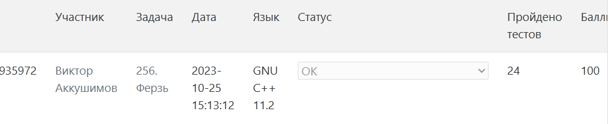

K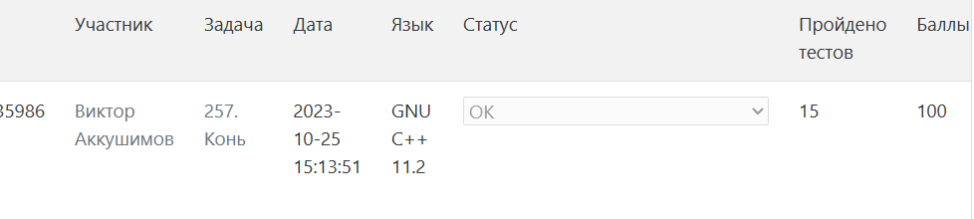

M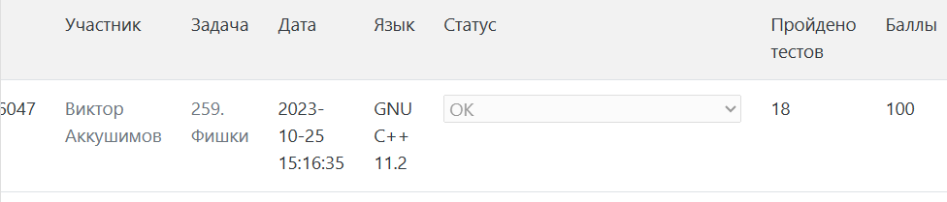

R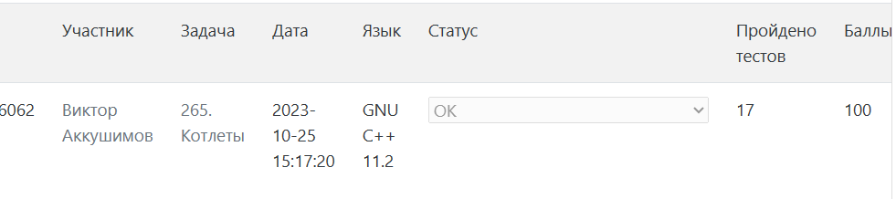

V